Deep Learning
4. Convolutional Neural Networks (CNN): Supervised Learning
4.1 Convolution operation, Padding, Stride, Relation between input, output and filter size, CNN architecture: Convolution layer, Pooling Layer, Weight Sharing in CNN, Fully Connected NN vs CNN, Variants of basic Convolution function, Multichannel convolution operation,2D convolution.
4.2 Modern Deep Learning Architectures: LeNET: Architecture, AlexNET: Architecture, ResNet: Architecture.
PAST QUESTIONS:
- Explain CNN architecture in detail. Suppose, we have input volume of 32*32*3 for a layer in CNN and there are ten 5*5 filters with stride 1 and pad 2; calculate the number of parameters in this layer of CNN. (D23)
- Describe LeNET architecture. (D23)
- Explain Pooling operation in CNN. (M24, D24)
- Explain the architecture of CNN with the help of a diagram. (M24)
- Explain and analyze the architectural of AlexNet Convolution Neural Network. (D24)
- Consider a CNN layer with the following configuration:
The input to the layer has 32 channels and a spatial size of 64×64.
The convolutional layer has 64 filters (kernels), each of size 3×3, with a stride of 1 and no padding.
Each filter is applied to every channel of the input.
Calculate the total number of parameters (weights) in this convolutional layer. (D24)
- Explain basic working of CNN. (M25)
- Draw and explain any two modern deep learning architectures. (M25)

NOTES:

*CNN :-
Convolutional Neural Network (CNN) is an advanced version of artificial neural networks (ANNs), primarily designed to extract features from grid-like matrix datasets. This is particularly useful for visual datasets such as images or videos, where data patterns play a crucial role. CNNs are widely used in computer vision applications due to their effectiveness in processing visual data.
CNNs consist of multiple layers like the input layer, Convolutional layer, pooling layer, and fully connected layers.
Architecture –
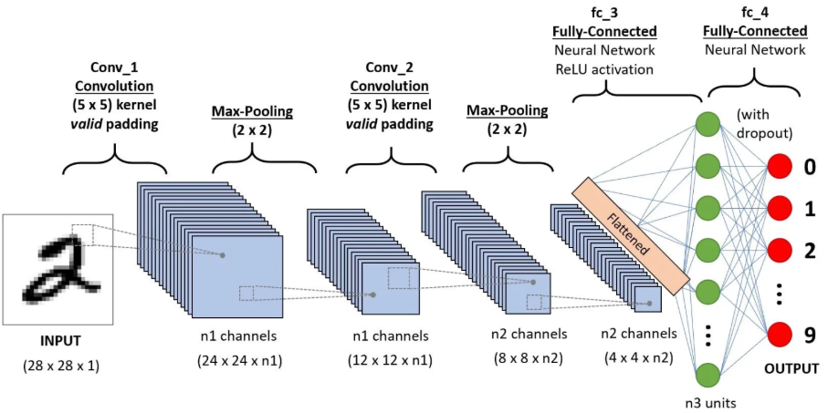

- Input Layers: It’s the layer in which we give input to our model. In CNN, Generally, the input will be an image or a sequence of images. This layer holds the raw input of the image with width 32, height 32, and depth 3.
- Convolutional Layers: This is the layer, which is used to extract the feature from the input dataset. It applies a set of learnable filters known as the kernels to the input images. The filters/kernels are smaller matrices usually 2x2, 3x3, or 5x5 shape. it slides over the input image data and computes the dot product between kernel weight and the corresponding input image patch. The output of this layer is referred as feature maps. Suppose we use a total of 12 filters for this layer we’ll get an output volume of dimension 32 x 32 x 12.
- Activation Layer: By adding an activation function to the output of the preceding layer, activation layers add nonlinearity to the network. Some common activation functions are RELU: max (0, x), Tanh, Leaky RELU, etc. The volume remains unchanged hence output volume will have dimensions 32 x 32 x 12.
- Pooling layer: This layer is periodically inserted in the covnets and its main function is to reduce the size of volume which makes the computation fast reduces memory and also prevents overfitting. Two common types of pooling layers are max pooling and average pooling. If we use a max pool with 2 x 2 filters and stride 2, the resultant volume will be of dimension 16x16x12.
- Flattening: The resulting feature maps are flattened into a one-dimensional vector after the convolution and pooling layers so they can be passed into a completely linked layer for categorization or regression.
- Fully Connected Layers: It takes the input from the previous layer and computes the final classification or regression task.
- Output Layer: The output from the fully connected layers is then fed into a logistic function for classification tasks like sigmoid or softmax which converts the output of each class into the probability score of each class.

*Padding :-
Padding is a technique used to preserve the spatial dimensions of the input image after convolution operations on a feature map. Padding involves adding extra pixels around the border of the input feature map before convolution.
This can be done in two ways:
- Valid Padding: In the valid padding, no padding is added to the input feature map, and the output feature map is smaller than the input feature map. This is useful when we want to reduce the spatial dimensions of the feature maps.
- Same Padding: In the same padding, padding is added to the input feature map such that the size of the output feature map is the same as the input feature map. This is useful when we want to preserve the spatial dimensions of the feature maps.
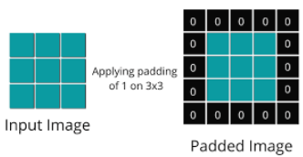

*Stride :-
Stride is the number of pixels by which the filter (kernel) moves over the input image during convolution.
A larger stride skips more pixels, reducing output size, while a smaller stride captures more details.
Need:
- Controls the spatial resolution of feature maps.
- Helps in reducing computation and adjusting feature granularity.
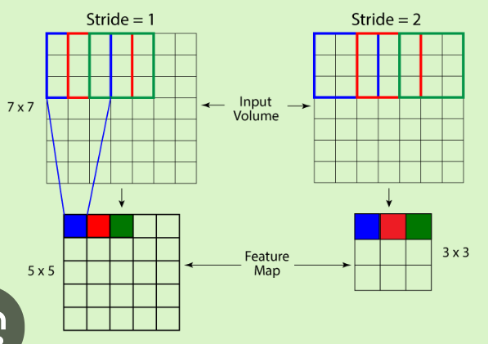

*FC vs CL :-
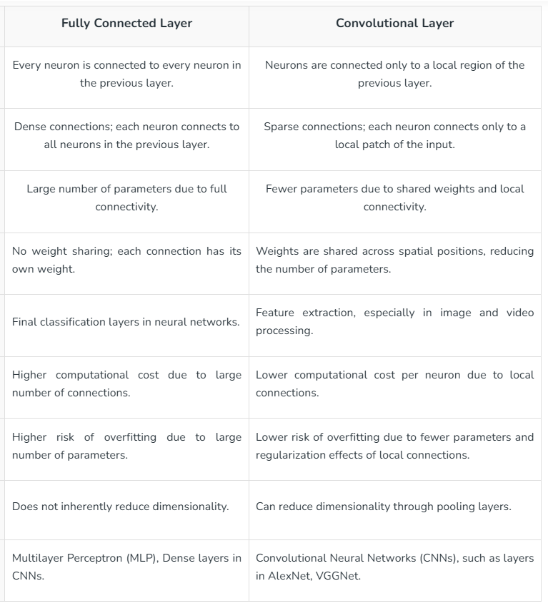

*LeNet :-
LeNet-5, proposed by Yann LeCun in 1998, is one of the first successful Convolutional Neural Networks (CNNs).
It was designed for handwritten digit recognition (MNIST dataset).
The LeNet-5 CNN architecture has seven layers. Three convolutional layers, two subsampling layers (pooling layers), and two fully linked layers make up the layer composition.
It has 7 layers (excluding input) including convolution, pooling, and fully connected layers.
Architecture Overview
- Input Layer:
Takes a 32×32 grayscale image as input.
- C1 – Convolution Layer:
Applies 6 filters of size 5×5, producing 6 feature maps of size 28×28.
Detects simple features like edges and corners.
- S2 – Subsampling (Pooling) Layer:
Performs average pooling with a 2×2 window and stride 2 → reduces size to 14×14.
Helps in reducing computation and maintaining spatial relationships.
- C3 – Convolution Layer:
Uses 16 filters of size 5×5 → outputs 16 feature maps of 10×10.
Learns more complex patterns.
- S4 – Subsampling Layer:
Another average pooling layer, reduces size to 5×5.
- C5 – Fully Connected Layer:
Contains 120 neurons connected to the previous layer.
Acts as a bridge between feature extraction and classification.
- F6 – Fully Connected Layer:
Has 84 neurons, applies non-linearity for better decision making.
- Output Layer:
10 neurons (for digits 0–9) with Softmax activation to output class probabilities.

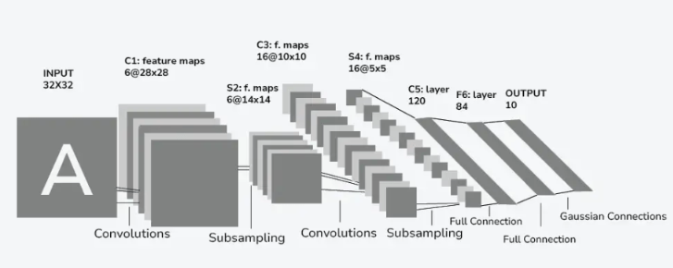

*AlexNet :-
- AlexNet was the first large scale Convolutional Neural Network.
- This was the first architecture that used GPU to boost the training performance.
- AlexNet had very similar architecture to LeNet but it was deeper, bigger and featured convolutional layers stacked top of each other.
- The AlexNet architecture consists of 5 convolutional layers & 3 pooling layers followed by 3 fully connected layers.
- It also included a normalization layer and ReLU activation function on every layer except the output layer.
- Here the convolution layers are responsible for learning features from the input image while the pooling layer is responsible for reducing the spatial dimensionality, and fully connected layers for classification.
- AlexNet follows a feed forward approach, meaning the output of one layer is used as input in another layer.
The AlexNet Architecture consists of the following layers:
i) Input layer
ii) Convolutional layer (5 layers)
iii) Pooling layer (3 layers)
iv) Fully connected layer (3 layers)
v) Output layer
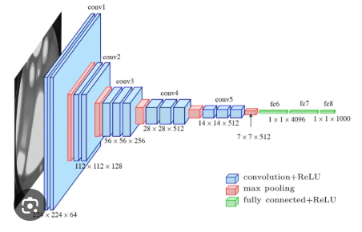

*ResNet :-
ResNet was introduced by Kaiming He et al. in 2015.
It solved the vanishing gradient problem in very deep networks by introducing skip connections.
In order to solve the problem of the vanishing/exploding gradient, this architecture introduced the concept called Residual Blocks. In this network, we use a technique called skip connections.
The skip connection connects activations of a layer to further layers by skipping some layers in between.
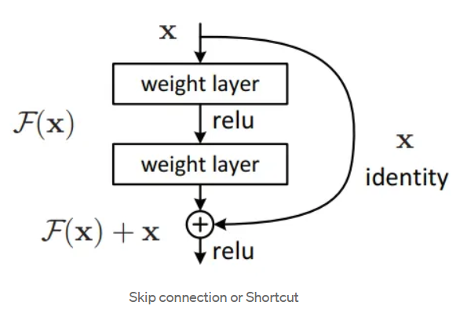
This forms a residual block. ResNets are made by stacking these residual blocks together.
The advantage of adding this type of skip connection is that if any layer hurt the performance of architecture then it will be skipped by regularization.
As a result, training an extremely deep neural network is possible without encountering issues with vanishing or expanding gradients.
This is how ResNet solved the problem of vanishing gradient.
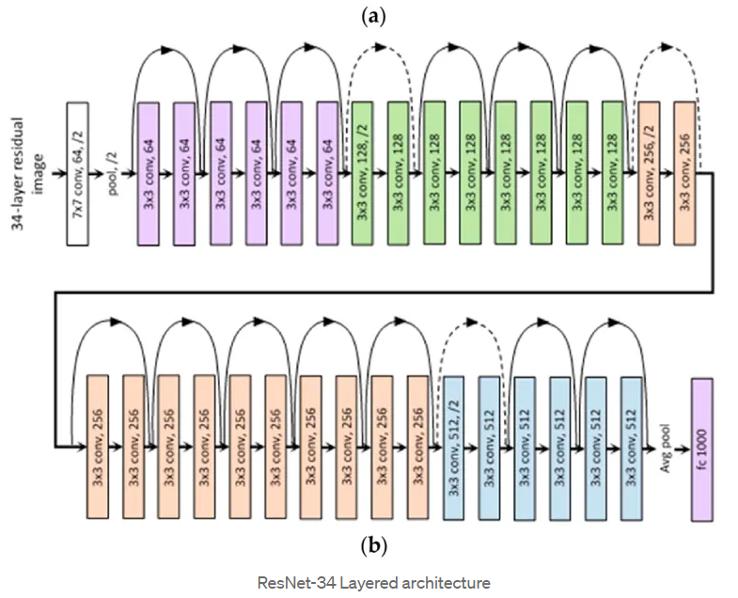
General Architecture (ResNet-34 example)
- Input: Image (e.g., 224×224×3)
- Conv1: 7×7 convolution with 64 filters, stride 2 → feature map
- Max Pooling: 3×3, stride 2
- Residual Blocks (4 stages):
  - Conv2_x: 3 residual blocks (64 filters each)
  - Conv3_x: 4 residual blocks (128 filters each)
  - Conv4_x: 6 residual blocks (256 filters each)
  - Conv5_x: 3 residual blocks (512 filters each)
Each block contains 3 convolutional layers with Batch Normalization, ReLU, and a skip connection.
- Average Pooling: Reduces feature map to 1×1
- Fully Connected Layer: Outputs 1000 classes (ImageNet dataset) using Softmax.

